Case 9-MEX-Michoacan-Female-Feather Headdress-Terra cotta-500 BCE

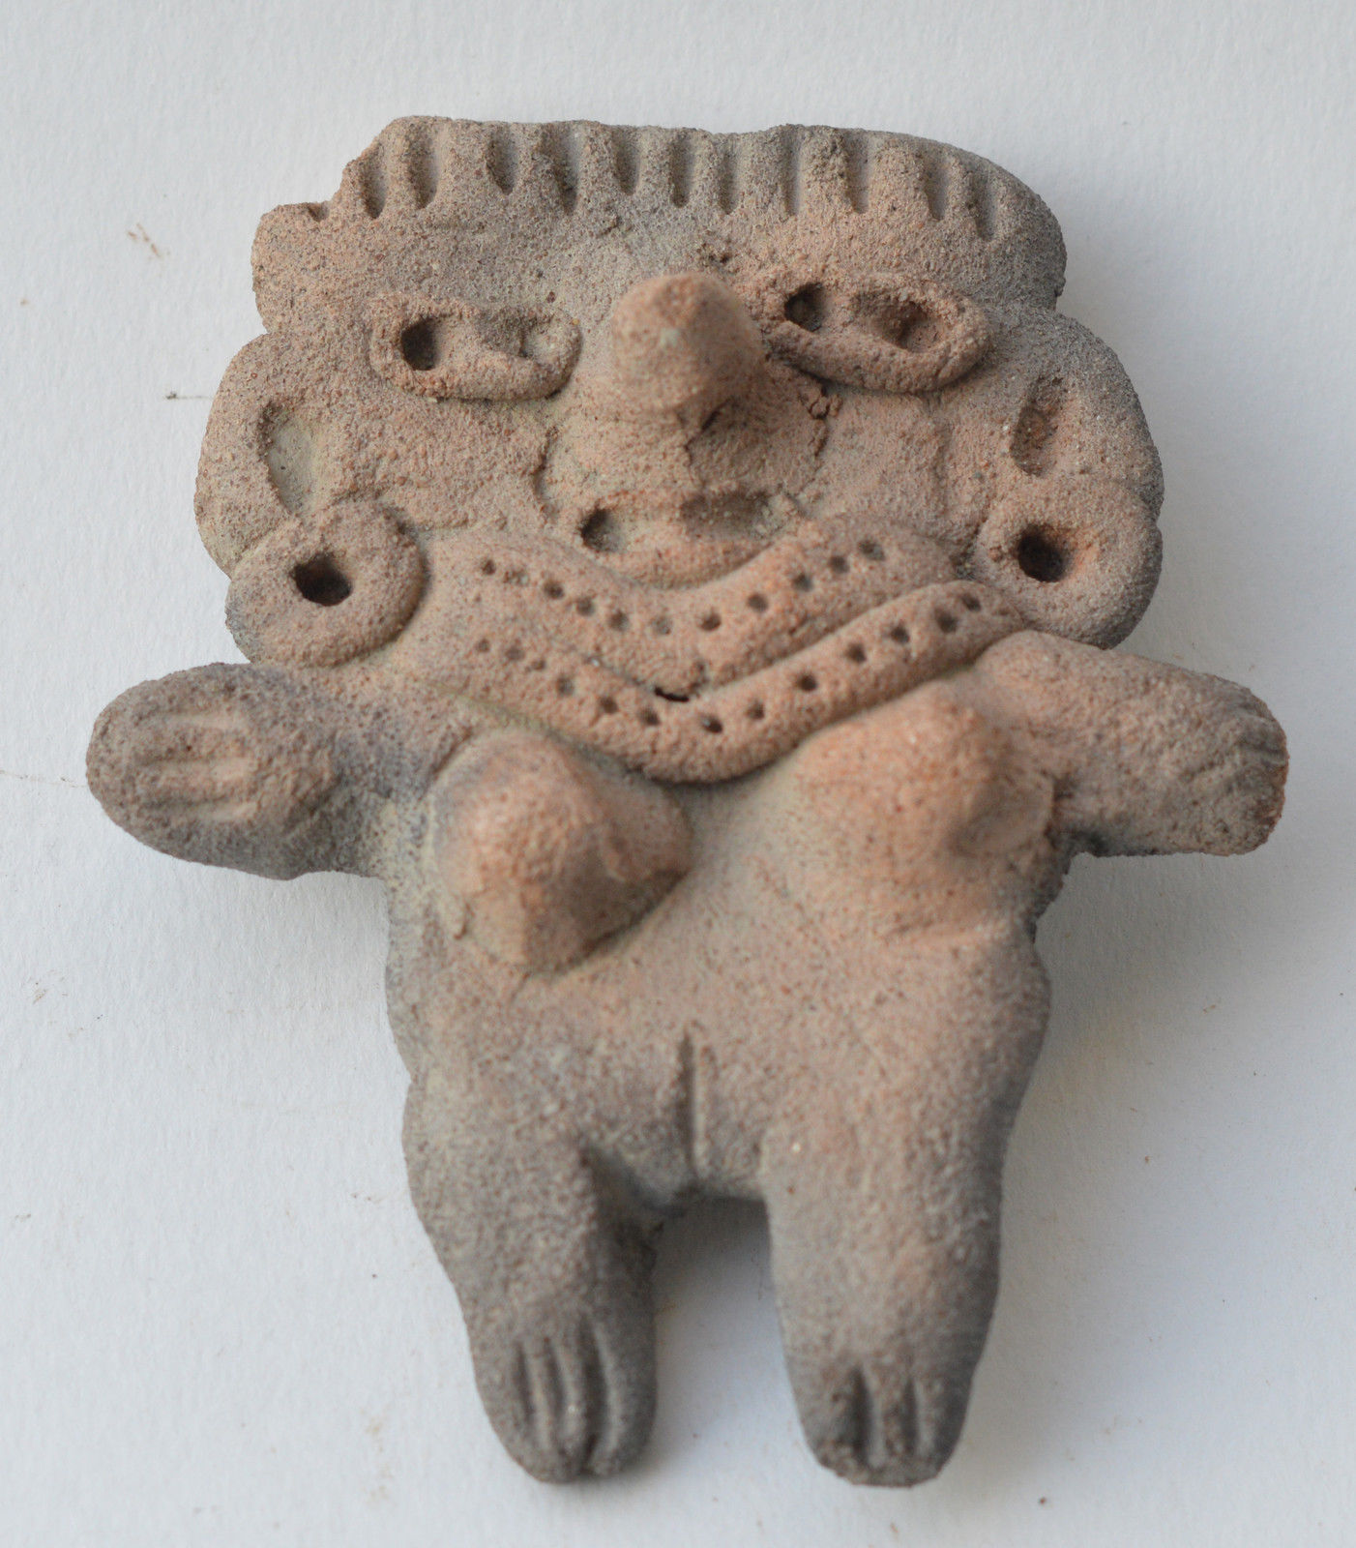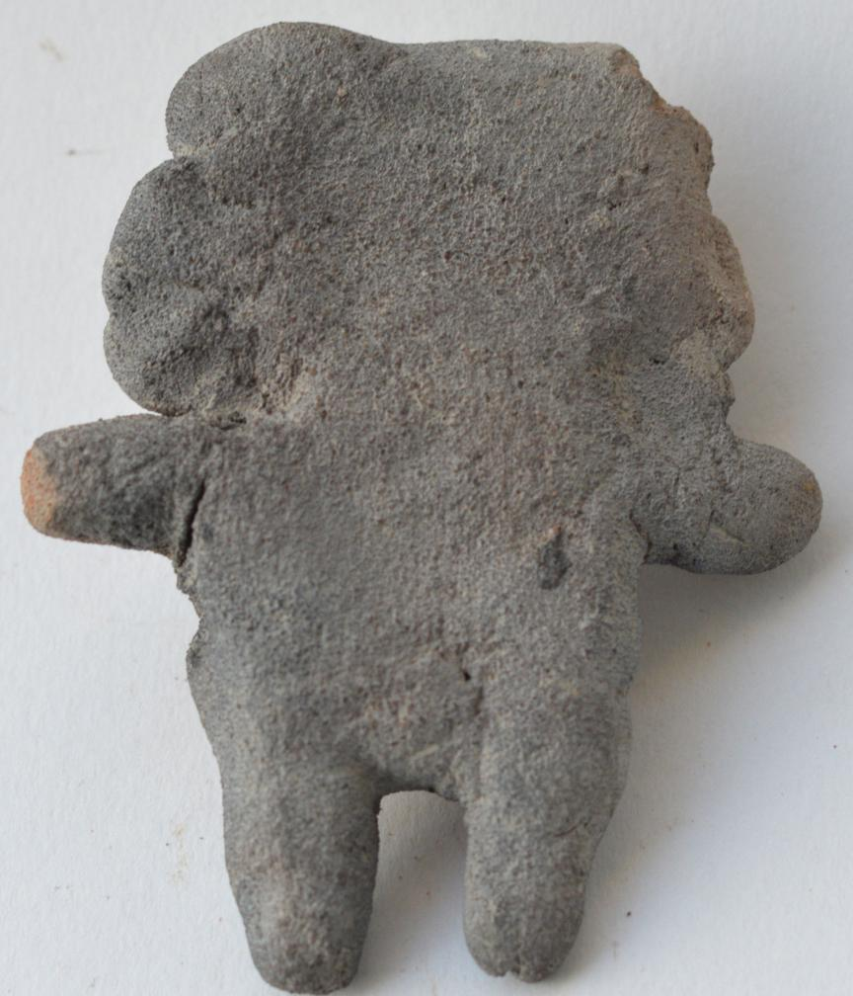

**Formal Label: Michoacan Female Figurine, ca. 500 BCE**

**Accession Number:** F1219.A3

**Date or Time Horizon:** 500 BCE

**Geographical Area:** Mexico

**Cultural Affiliation:** Michoacan

**Medium:** Terracotta

**Dimensions: H** 8 cm

**Weight:**

**Provenance:** Netherlands collection

**Condition: original**

**Discussion:**

**References:**